How to Slant cells in Google Sheets

In Google Sheets, slanting or rotating cells allows you to change the orientation of the text within a cell. Instead of the default horizontal alignment, where text runs from left to right, you can tilt the text at an angle to add emphasis or improve the visual appearance of your spreadsheet.

In the tutorial today, we'll focus on slanting cell headers to enhance their visibility. We'll learn various methods and step-by-step instructions to effectively implement this visually appealing presentation style.

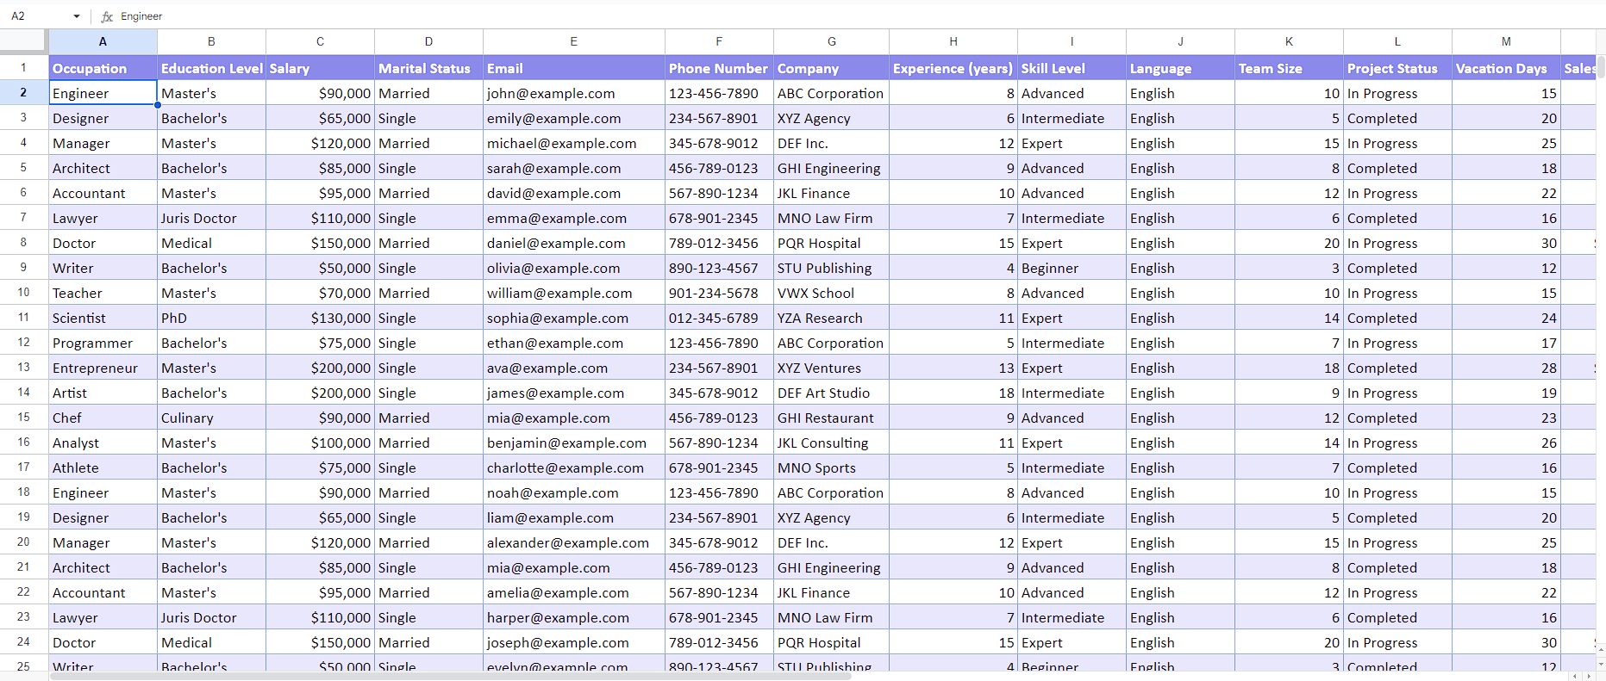

## Step 1 – Select the cells

* Select the cells that you wish to format as slanted text.



## Step 2 – Slant the cells

* After that navigate to the “Format” tab and click on the “Rotation”.
* Now, you will see a drop-down menu containing list of options on your screen.
* Click on “Tilt up” or “Tilt down” to slant the cells.

